Team: Ahmet Gungor | Sathi Sikdar | Ashwin Kondapalli Vinay Singh | Utkarsh Pandey

THe university of texas at dallas | fall 2018 | BUAN 6312.003

Econometrics Project – BUAN 6312

Effect of drinking laws on car fatalities

**Table of Contents**

1. Introduction………………………………………………………………………………………………………………………….2

2. Descriptive Analytics……………………………………………………………………………………………………………..3

3. Analysis……………….…………………………………………………………………………………………………….………….9

4. Conclusions…………………………………………………………………………………………………………………….……16

5. STATA Code………………………………………………………………………………………………………………………….18

**1.0 Introduction**

Following steps describe data exploration, analysis, and conclusion processes done by our group on the car fatalities data. Our goal with this project is to find out which drinking laws have a significant effect on car fatalities based on the data that cover 48 states from 1982 through 1988. However, before we look at the analysis of the data, we need to understand it.

Data consists of the following variables:

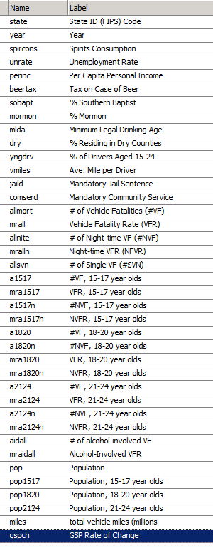

**2.0 Descriptive Analytics**

First of all, we explored the summary of all the variables. We looked at the mean, standard deviation, minimum and maximum values. We tried to see which variables had a high variance and which were dummy variables. Based on the summary table, we found that variables sobapt, mormon and dry had high variances compared to their mean, but we also realized that these variables are based on a percentage, so these variances should not be unusual based on their distributions among 48 states. We also found out that jaild and comserd were dummy variables which represent states’ laws against car accidents based on drunk driving.

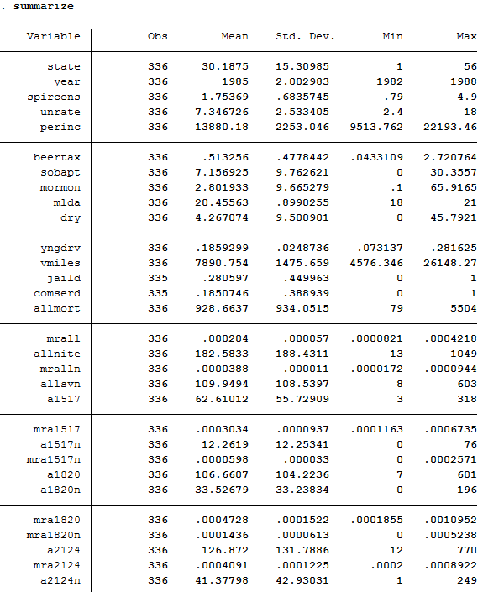

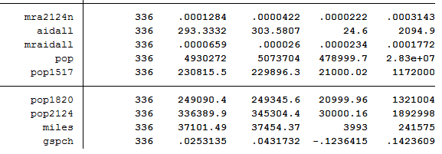

After reading in the data with 48 states and 7 time periods, we looked at the between and within variation of the variables that seemed important to us based on our take on the project. Oddly enough, none of those variables had within variation that were 0, which meant that none of these variables were time invariant explanatory variables. This early stage data exploration hinted us to use fixed effects estimator for our data analysis.

Then, we wanted to see which variables’ distribution had a long right tail. To find this out, we built histograms of the suspected variables. It turned out that mrall, beer tax, pop2124, perinc, and spircons had histograms with a right tail. To avoid these tails affecting our analysis, we took log of the mentioned variables. Below, you can see the histograms.

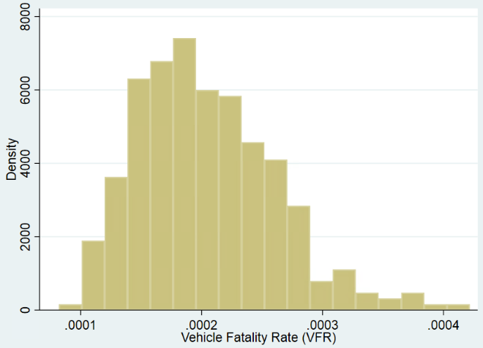Mrall:

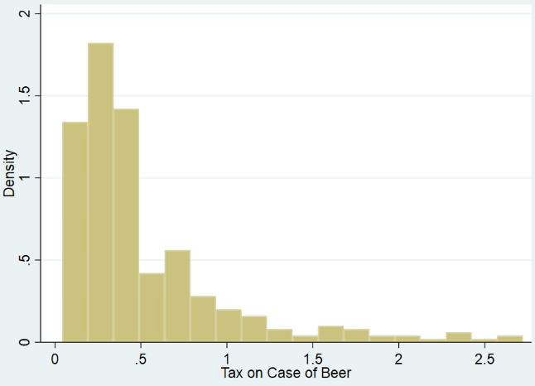Beer tax:

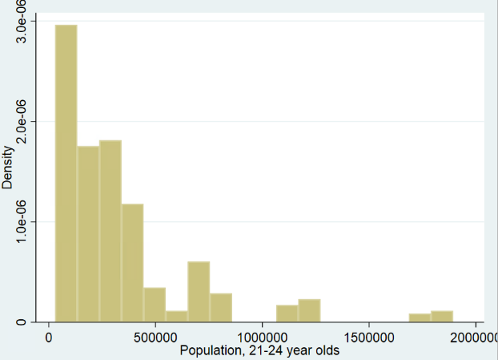Pop2124:

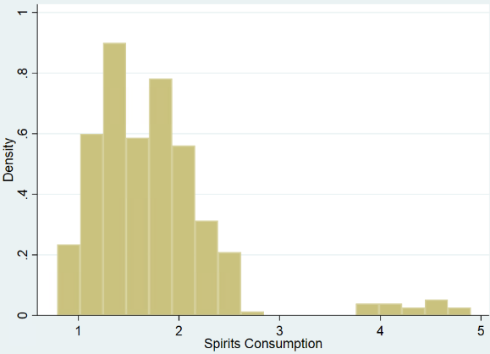Spircons:

Then, we looked at some of fitted lines between our chosen dependent variable, mrall, which is the vehicle fatality rate, and the independent variables that we chose.

The first thing we saw here was that the relationship between beer tax and the vehicle fatality rate was positive, meaning that as beer tax increased, vehicle fatality rate also increased. This was an interesting concept, since one normally would expect the relationship to be negative. This led us to think the reason behind it was simultaneous causality bias. This bias happens when not only the independent variables affect the dependent variable, but the dependent variable affects the independent variables as well. In this case, beer taxes may have been increased in the states that already consume lots of alcohol, or there may be a cultural effect that needs to be included in this equation for the equation to make more sense. However, simultaneous causality bias did not just affect beer tax in this case. It also affected other variables such as spircons, which had a negative relationship with mrall, which meant that as the alcohol consumption increased, vehicle fatality rate decreased.

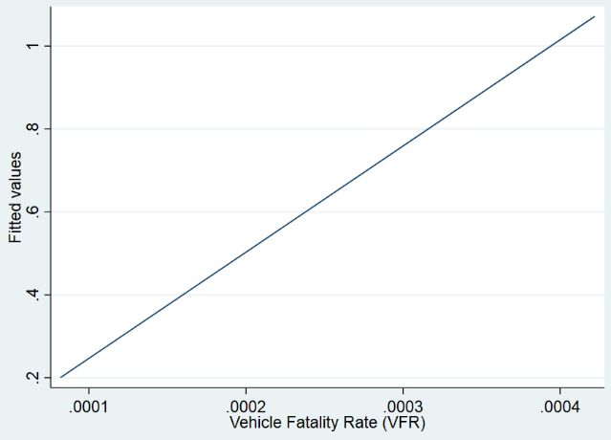Beer tax and the vehicle fatality rate:

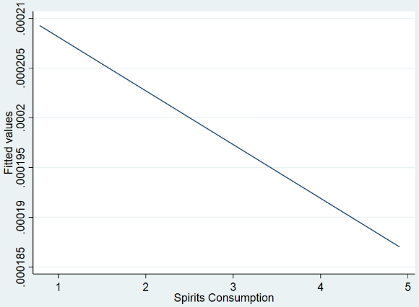

Spircons had a negative relationship   
with mrall:

After a few more basic linear fittings, we found out that as population increased, beer tax slowly decreased. When it came to the beertax change across time and states, most states that had relatively lower beer taxes did not change their beer tax during these seven years. However, the states with relatively higher beer taxes slowly decreased their beer taxes over time. (Figure 1)

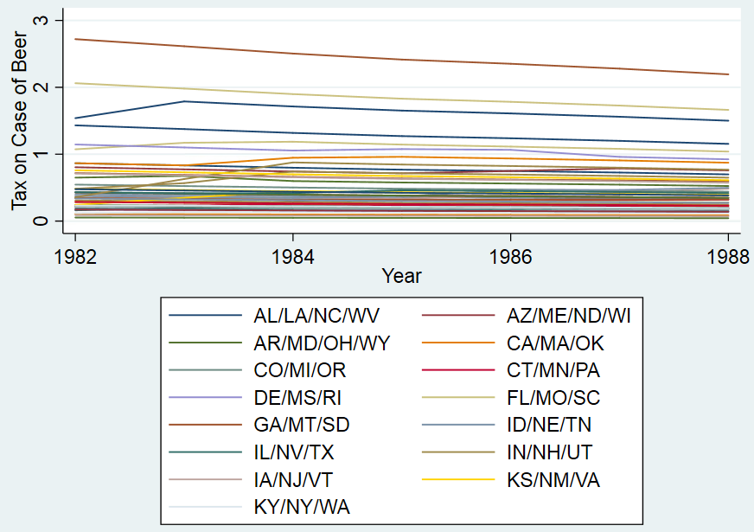

Figure 1: The states with relatively higher beer taxes slowly decreased their beer taxes over time

With the above-mentioned relationship in mind, we also looked at the alcohol consumptions across states and year which helped us understand the decreasing beer taxes. It turns out that alcohol consumption was slowly decreasing across majority of states over time. By looking at the below overlay graph, we realized that some states had much higher alcohol consumption, which made us look further into this topic. After grouping consumption by states, we found that Nevada and New Hampshire both had very low population but two of the highest alcohol consumptions in the country. We took note of these states as potential outliers in the x direction. (Figure 2)

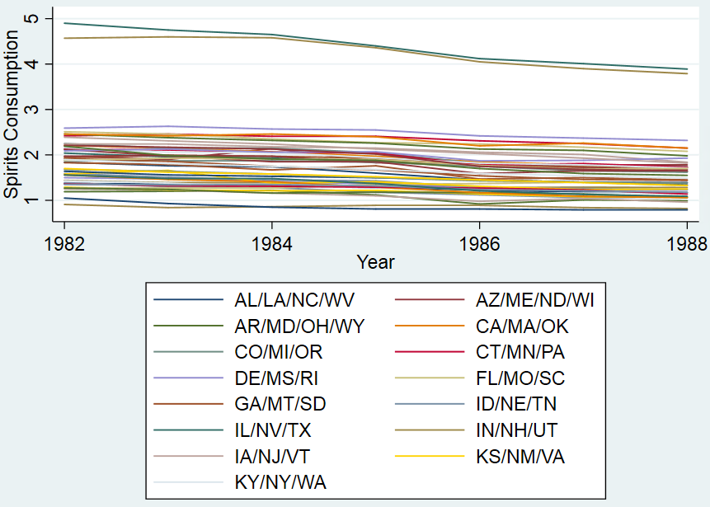

Figure 2: The alcohol consumptions across states and year

After these simple linear fitting graphs, we wanted to have a more detailed look on the vehicle fatality rate, beertax, and the population between ages 21-24, when it becomes legal to consume alcohol in the United States. We explored these variables based on year and state separately, including their mean values in our graphs. Figure 3 shows vehicle fatality rate across states and their mean with a red circle, while the blue circles represent the values across time. Here, we noticed that some states have values that are grouped tightly while some other have higher variation across time. Then, we made the graph using year as a group by value to clearly see what happened to the mean vehicle fatality rate over time. Based on Figure 4, across 48 states, the mean fatality rate remained constant over time. After running the same graphs on beer tax and pop2124, we found that beer tax and population between ages 21-24 slowly decreased over time nationwide.



Figure 3: Vehicle fatality rate across states and their mean with a red circle, while the blue circles represent the values across time



Figure 4: The mean fatality rate remained constant over time

As a final step on our data exploration, we investigated some possible correlations among the variables that we were interested in. Some of the highest correlations we found were:

0.5236 between comserd – jaild

-0.3951 between beertax – perinc

0.4548 between spircons – perinc

-0.5525 between unrate – perinc

-0.4741 between yngdrv – perinc

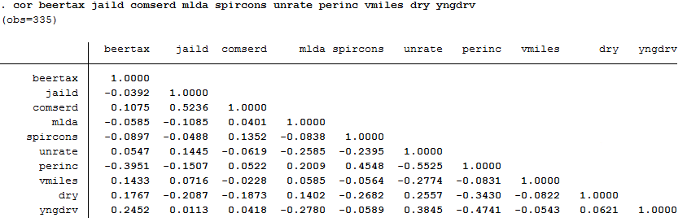

Figure 5: Correlations

Based on these findings, we concluded that per capita personal income is correlated with most of the explanatory variables that we chose. So, we decided to handle perinc with care during our analysis to avoid omitted variable bias and autocorrelation, although the correlations were not at critical stages.

**3.0 Analysis**

We started our analysis by building an OLS model, where we threw in every variable that we think is important in this project. We chose mrall, the vehicle fatality rate, as our dependent variable, because it lines up better with this project’s goals than the other possible dependent variables from the dataset. Since mrall is a rate, it also helps us control for the population of states without including the population as an independent variable. As for the independent variables of our OLS model, we first started with the variables that represent a law such as beer tax, jaild, comserd, and mlda. Then, we included socio-economic factors such as spircons, unrate, perinc. After that, we investigated population dynamics and included vmiles, dry, yngdrv, and pop2124 to our raw model. We used log versions of the variables that were skewed for our analysis. Based on the results of this first OLS model, we had a general idea of what needs to be worked on for this project. For instance, in our first model, minimum legal drinking age, beertax, unemployment rate, % living in dry counties and population between ages 21 and 24 were highly insignificant. The signs on some variables like mlda were also unexpected, however, we already explored some of this in the previous section, so we were not surprised. Then, we wanted to add and check for joint significance of the year dummies in this OLS model so that we can compare later with our fixed effects model. Although, majority of the year dummies were insignificant at 5% level, they were jointly significant to the model.

After we were done with our preliminary OLS analysis, we checked for heterogeneity for the OLS model that contains year dummies. We ran a white test and found out that heterogeneity exists in the data as shown in Figure 6. As discussed before in the data exploration section of this project, the heterogeneity in our case is mostly due to unobserved characteristics which are most probably correlated with the explanatory variables in our model. This would lead us to have an endogeneity problem which will hinder us from using a random effects model in the future. The robust standard errors corrected OLS model still had the same insignificant variables expect pop2124, which was significant for the corrected model. However, this correction made all the year dummies insignificant.

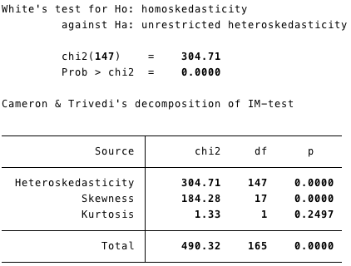

Figure 6

What we learned from the OLS model confirmed our suspicions about the data. Since we had a possible endogeneity problem, the least square estimators for some variables were biased and inconsistent. Therefore, we decided to build a fixed effects model that would control for individual heterogeneity in both observed and unobserved variables, eliminating the effect of time-invariant omitted variables from the model. Since our fixed effects model would only depend on the within state variation, our results would be unbiased and consistent estimators for the variables that are endogenous in the OLS model. So, we made our initial OLS model into a fixed effects model and ran it with cluster robust standard errors without the year dummies. Overall, explanatory variables became less significant, but they had their expected signs. Positive signs on the coefficients of jaild and comserd became negative. But, most of our variables were not significant. So, we added in the year dummies and tested for their joint significance to the model. Adding these dummies decreased the overall significance of the explanatory variables and made jaild insignificant at 5% level as shown in Figure 7, which was very significant in the previous model.

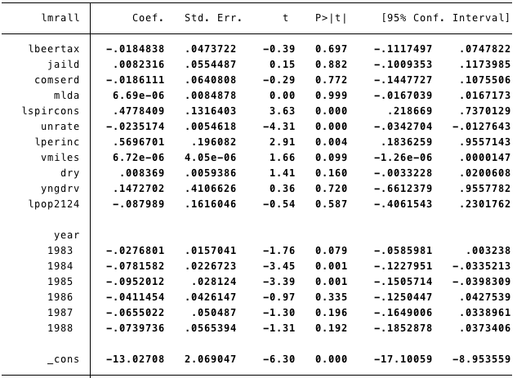

Figure 7

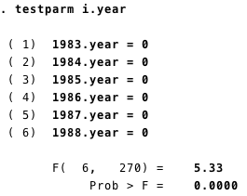Although the effects were apparent, we tested for the joint significance of the year effects. In Figure 8, you can see that the p-value for the F-test is 0. So, these dummy variables were jointly significant to the model.

Figure 8:

Then, we built a random effects model with the same dependent and explanatory variables to conduct a Hausman Test. This test would allow us to check for any correlation between the random effect component and its regressors. Based on this test, we could be certain that there was endogeneity in the random effects model and confirm that fixed effects model is the model we should use. As shown in Figure 9, we reject the null hypothesis in the Hausman test, which means that there is endogeneity in the random effects model and we should choose fixed effects model.

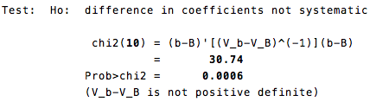

Figure 9

After confirming the validity of our fixed effects model, we decided to compare our current model, which is written below, with some non-logged models to see if we did a good job taking the log of the variables. For this comparison, we used AIC and BIC values of our models. The log model below had a BIC of 796.88, while the non-logarithmic version had a BIC of over 6489. This huge difference confirmed that logarithmic equations are the way to go. However, after playing with the non-logarithmic model for a while, we found out that most of the increased BIC went away if we just took the log of the dependent variable mrall and explanatory variable perinc. Although this was the case, we still acquired better results with the current logarithmic model. So, we decided to keep them.

Logarithmic Model Before Model Improvements

--xtreg lmrall lbeertax jaild comserd mlda lspircons unrate lperinc vmiles dry yngdrv lpop2124 i.year, fe cluster(state)---

This is when we started to improve our model. First, we ran several regressions that we thought would be best for this project. From the original logarithmic model that has been written above, we gradually removed insignificant variables to see their effects and included several test interaction variables such as c.lperinc#c.lbeertax c.lperinc#c.lspircons c.lperinc#c.unrate to our model based on the correlation matrix we discussed earlier. Based on the F test, these interaction variables were jointly significant to the model.

Then, we went for the lowest BIC that we could get. Below model had a BIC around -813 which was the lowest we got without letting go of the law variables that we need in the equation. Here, we learnt a valuable lesson, which was how to correctly interpret BIC when it is negative. Before we learnt that we should look at the smallest value even if it is negative, we looked at the absolute value of BIC. By doing so, as we kept adding variables to the model, BIC kept dropping instead of rising. As well, adding variables made almost every other variable insignificant to the model as shown partly in Figure 10. It was here that we added the interaction variable i.comserd#c.lspircons to the model as we thought it would help us explain the relationship better. Just to make sure, we ran a stepwise regression with the same model. The results included the same insignificant coefficients since stepwise regression was based on increasing the R squared. However, this approach was all wrong, because we interpreted the negative BIC incorrectly. To confirm that we should not look at the absolute value of a negative BIC, we chose to do some F tests on the model. First, we tested the joint significance of the variables we added to decreased BIC which were lpop2124, lpop1820, lpop1517, sobapt, Mormon and gspch. These were all insignificant to the model with a F(6,47) = 2.18 and P value = 0.0616. So, we decided to drop these from the equation to get better results. Then, we tested for all of the explanatory variables that originated from a state law which were lbeertax, jaild, 1.comserd#c.lspircons, comserd and mlda. With a p value 0.0475, these were jointly significant. After that, we tested for dry, vmiles and yngdrv which were all poorly performing variables. But, they turned out to be jointly significant at 5% level. Then, we tested for lspircons and lperinc separately. Alcohol consumption was very significant as expected, whereas per capita income was not significant in this equation. However, we could not omit this variable. Since it had high correlation with other explanatory variable, it would cause an omitted variable bias.

Model with Lowest BIC (At this stage)

---xtreg lmrall lbeertax jaild comserd mlda lspircons unrate lperinc i.year, fe cluster(state)---

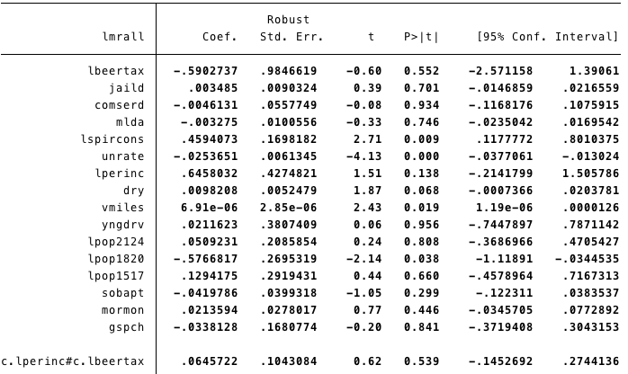

Figure 10

With those, F tests ended, and we reached a refined model:

xtreg lmrall lbeertax jaild i.comserd#c.lspircons comserd mlda lspircons unrate lperinc dry vmiles yngdrv c.lperinc#c.lbeertax i.year, fe cluster(state).

At this stage, we had a question in mind. Whether including beertax without its logarithmic form would be beneficial for our model. We converted beertax and its interaction variables into normal forms and tried regression different models. While doing this, we discovered that the variable yngdrv was doing more damage to the model than benefit and that is why we removed it. As well, we added the interaction variables c.lspircons#c.mlda to the model. We found this term along the way because of trial and error, which turned out to be helpful in explaining the effect of alcohol consumption. In the end, the models with beertax over log(beertax ) had worse significance on beer tax. So, we chose to continue with log(beertax) after answering this question.

Before declaring our final model, we would like to mention that determining the final model took a couple of days. Since we tried all the variable combinations that could improve the model, we cut down some of the process in the stata code to make our code look cleaner. So, the stata code does not reflect the full process of achieving this model, but it summarizes all the vital points in deciding on one model. Otherwise, the code would be a mess that is very hard to understand.

After determining to use log(beertax), our current model looked like this:

xtreg lmrall lbeertax jaild i.comserd#c.lspircons comserd mlda lspircons c.lspircons#c.mlda unrate lperinc dry vmiles c.lperinc#c.lbeertax i.year, fe cluster(state)

This is when we realized that we did not include the interaction term between alcohol consumption and per capita income to the model. This interaction term could help us decrease the unexplained variance in the model since there should be a significant relationship between these two explanatory variables. The results supported our hypothesis. Adding this single interaction term made lbeertax and c.lperinc#c.lbeertax variables significant at 5% level, which were both very insignificant previously. It also made lperinc more significant. Another major improvement to the model was to remove comserd from the model and add its effect to the interaction variable comserd#c.lspircons. This resulted in better beer tax and jaild significance.

After these two adjustments, jaild variable was still very insignificant. So, we decided to look into that. After trying a bunch of different variable combinations to find out a way to explain jaild better, we realized that an interaction term between jaild and comserd actually made a jaild more significant, however, it was still not significant enough to consider it effective.

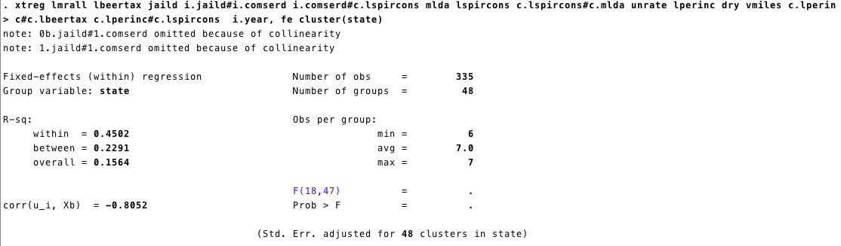

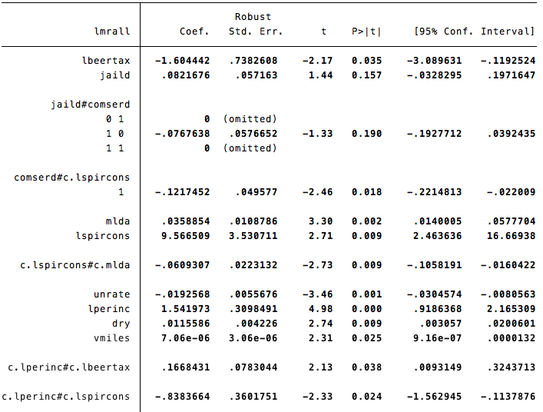

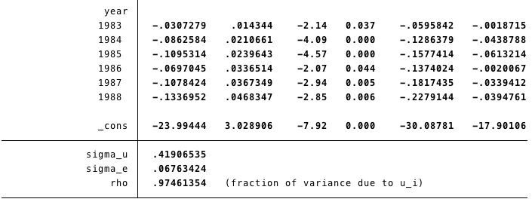

Figure 11: The final model

The final model we decided upon is shown in Figure 11. This was the model that took into consideration every relationship that we found during our data exploration and yielded the best significance without omitting any important variable.

In this model, every explanatory variable is significant at 5% level except jaild and its interaction variable. Surprisingly our final model had even lower BIC (-824) than we could find while we attempted to find the lowest BIC, and it does a better job at explaining the relationships between explanatory variables and their relationship to car fatality rates across 48 states. Based on these estimations, some state laws work and some others do not work as much which are discussed in the following section.

**4.0 Conclusions**

Let’s start our conclusion by interpreting our final model. Based on this model, beer taxes and minimum legal drinking age seem to be working laws across 48 states for decreasing vehicle fatality rate. Mandatory community service seems to be only significant when the person who is involved in the car accident has consumed spirits (alcohol). On the other hand, mandatory jail sentence seems to not work. This may be because most car accidents that require a mandatory jail sentence have already resulted in a fatality and that is why we could not get a good and significant estimate on this variable.

When we look at the model, we see that a 1% increase in the beertax is associated with a 1.604% decrease in the vehicle fatality rates for states with lower per capita income, other factors held constant. For states that have relatively higher per income capita, this effect goes down to (1.6044-0.1668=1.4376) 1.4376%.

If a state has a mandatory jail time law in action, then this state would have vehicle fatality rate that is (0.0822-0.0768 = 0.0054) 0.54% higher than the states that do not have this law in action. This seems unlikely to be true and jaild variable is insignificant at 5% level. An additional year of minimum legal drinking age is associated with a 3.589% increase in vehicle fatality rate for states with lower spirits consumption. For states with relatively higher spirits consumption, this effect changes to (0.0359 – 0.0609 = -0.025) a 2.5% decrease in vehicle fatality rate.

Interpreting spirits consumption is harder and requires more intuition. What we can say is that for states that do not have a community service law in order and have relatively lower per income capita, a 1% increase in spirits consumption is associated with a 9.57% increase in the vehicle fatality rates. This rate goes down by only small amounts when a state has a community service law in order, or it has relatively higher per income capita.

A point increase in unemployment is associated with a 1.93% decrease in vehicle fatality rate. This might be explained by the fact that people who are unemployed will be less likely to consume alcohol, decreasing the likelihood of a vehicle accident.

Per capita income also is a hard variable to interpret since it is interacting with a lot of variables due to high correlation in our model. But overall, the higher per capita income, the higher the likelihood of fatality is. Every 1% increase in per capita income is associated with a 1.54% increase in vehicle fatality rate if we approximate it.

When it comes to year dummies, we can see a decreasing trend, although the histogram of the year dummy estimates would have 2 peaks: one in 1985 and another in 1988. In 1983, the likelihood of a vehicle fatality was 3.07% less than in 1982 on average. In 1988, the same likelihood was 13.37% less than in 1982. So, as years passed, the vehicle fatality rate decreased. This may be due to better driving laws or people getting more knowledgeable about effects of alcohol to driving.

To summarize, we started our project by exploring car fatalities data. We looked at within and between variation, histograms, scatter plots and overlay graphs of the variables that we were interested in. We also studied the correlation matrix of the important variables. These exploration activities led us to see the patterns in our data. Certain variables had high correlation with other variables, and some variables had long right tails in their distributions. During our exploration process, we took note of such behaviors and fixed these problems in our data analysis.

We began analyzing our data by regressing simple OLS functions and testing for heteroscedasticity. After we confirmed that we have heteroscedasticity in our data, we went ahead and tried a fixed effect and a random effects model. We compared the results of these two models using a Hausman test, which revealed that we had an endogeneity problem in our dataset. So, we chose to continue with our fixed effects model. We tested the fixed effects model against logarithmic and non-logarithmic variables and improved it by including interaction terms. We constantly tested the validity of these interaction terms as well as our explanatory variables by conducting F-tests. If they were jointly significant to the model, we decided to keep them in our model until we changed our model further. If not, we removed them from our model, which improved the significance of the remaining variables. We also checked the AIC and BIC values of our models. Although we did not depend solely on these values, they helped us immensely on which way to go to improve our model.

After days of trying different combinations of variables, we came up with our final model. Based on this model, we concluded that beer tax and minimum legal drinking age laws have a negative significant effect on vehicle fatality rates. On the other hand, mandatory jail time and community service laws were not significant on their own. Based on the alcohol consumption, mandatory community service had some effect on vehicle fatality rates, but it was small compared to other significant laws.

**5.0 STATA Code**

**Class Project**

clear all

use "________________________________________ \car_fatalities.dta"

****************Data Exploration**************

**Set panel data

xtset state year

summarize

xtdescribe

xtsum year mrall beertax dry jaild perinc vmiles mraidall

xtsum year beertax pop pop1517 pop1820 pop2124

xtsum mrall beertax jaild comserd mlda spircons unrate perinc vmiles dry yngdrv

**Histograms

hist vmiles

hist pop2124

hist pop1820

hist pop1517

hist beertax

hist perinc

hist spircons

hist unrate

hist yngdrv

hist mrall

hist gspch

hist mralln

hist mraidall

gen lpop2124 = log(pop2124)

gen lpop1820 = log(pop1820)

gen lpop1517 = log(pop1517)

gen lbeertax = log(beertax)

gen lperinc = log(perinc)

gen lspircons = log(spircons)

gen lmrall = log(mrall)

gen lmralln = log(mralln)

gen lmraidall = log(mraidall)

**Basic Relationships

twoway lfit beertax mrall

twoway lfit mrall pop2124

twoway lfit mrall pop1820

twoway lfit mrall vmiles

twoway lfit mrall perinc

twoway lfit mrall pop2124

twoway lfit mrall jaild

twoway lfit mrall comserd

twoway lfit mrall spircons

**Beertax

xttab beertax

twoway (scatter beertax pop) (lfit beertax pop)

xtline beertax, overlay

**Spircons

xtline spircons,overlay

**Figuring out which states have low pop but high spircons

twoway scatter spircons pop, by(state)

twoway (scatter spircons pop) (lfit spircons pop)

**State and year groups

*Vehicle Fatality Rate

bysort state: egen mrall_mean=mean(mrall)

twoway scatter mrall state, msymbol(circle_hollow) || connected mrall_mean state,

msymbol(diamond) || , xlabel(state)

bysort year: egen mrall_mean1=mean(mrall)

twoway scatter mrall year, msymbol(circle_hollow) || connected mrall_mean1 year,

msymbol(diamond) || , xlabel(1982(1)1988)

*Beertax

bysort state: egen beertax_mean=mean(beertax)

twoway scatter beertax state, msymbol(circle_hollow) || connected beertax_mean state,

msymbol(diamond) || , xlabel(state)

bysort year: egen beertax_mean1=mean(beertax)

twoway scatter beertax year, msymbol(circle_hollow) || connected beertax_mean1 year,

msymbol(diamond) || , xlabel(1982(1)1988)

*Pop2124

bysort state: egen pop2124_mean=mean(pop2124)

twoway scatter pop2124 state, msymbol(circle_hollow) || connected pop2124_mean state,

msymbol(diamond) || , xlabel(state)

bysort year: egen pop2124_mean1=mean(pop2124)

twoway scatter pop2124 year, msymbol(circle_hollow) || connected pop2124_mean1 year,

msymbol(diamond) || , xlabel(1982(1)1988)

*mra2124n

bysort state: egen mra2124n_mean=mean(mra2124n)

twoway scatter mra2124n state, msymbol(circle_hollow) || connected mra2124n_mean state,

msymbol(diamond) || , xlabel(state)

bysort year: egen mra2124n_mean1=mean(mra2124n)

twoway scatter v year, msymbol(circle_hollow) || connected mra2124n_mean1 year,

msymbol(diamond) || , xlabel(1982(1)1988)

**Correlation Analysis

cor beertax pop2124

cor spircons vmiles

cor perinc spircons

cor unrate spircons

cor beertax perinc

cor beertax jaild comserd mlda spircons unrate perinc vmiles dry yngdrv

*****************Data Analysis*******************

**OLS Model

reg lmrall lbeertax jaild comserd mlda lspircons unrate lperinc vmiles dry yngdrv lpop2124

reg lmrall lbeertax jaild comserd mlda lspircons unrate lperinc vmiles dry yngdrv lpop2124 i.year

testparm i.year

**Test for heteroskedasticity

estat imtest, white

reg lmrall lbeertax jaild comserd mlda lspircons unrate lperinc vmiles dry yngdrv lpop2124 i.year, vce(robust)

**Fixed Effects Model

xtreg lmrall lbeertax jaild comserd mlda lspircons unrate lperinc vmiles dry yngdrv lpop2124, fe cluster(state)

xtreg lmrall lbeertax jaild comserd mlda lspircons unrate lperinc vmiles dry yngdrv lpop2124, fe

estimates store fixed

xtreg lmrall lbeertax jaild comserd mlda lspircons unrate lperinc vmiles dry yngdrv lpop2124 i.year, fe cluster(state)

testparm i.year

estat ic

**Random Effects Model

xtreg lmrall lbeertax jaild comserd mlda lspircons unrate lperinc vmiles dry yngdrv lpop2124, re

estimates store random

*Hausman Test

hausman fixed random

*Different models without log variables

xtreg mrall beertax jaild comserd mlda spircons unrate perinc vmiles dry yngdrv pop2124 i.year, fe cluster(state)

estat ic

xtreg lmrall beertax jaild comserd mlda spircons unrate lperinc vmiles dry yngdrv pop2124 i.year, fe cluster(state)

estat ic

**Model Improvements

xtreg lmrall lbeertax jaild comserd mlda lspircons unrate lperinc vmiles dry yngdrv lpop2124 i.year, fe cluster(state)

estat ic

xtreg lmrall lbeertax jaild comserd mlda lspircons unrate lperinc vmiles dry lpop2124 i.year, fe cluster(state)

estat ic

xtreg lmrall lbeertax jaild comserd mlda lspircons unrate lperinc dry lpop2124 i.year, fe cluster(state)

estat ic

xtreg lmrall lbeertax jaild comserd mlda lspircons unrate lperinc dry c.lperinc#c.lbeertax c.lperinc#c.lspircons c.lperinc#c.unrate i.year, fe cluster(state)

estat ic

stepwise

test lperinc c.lperinc#c.lbeertax c.lperinc#c.lspircons c.lperinc#c.unrate

test c.lperinc#c.lspircons c.lperinc#c.unrate

*Trying to find lowest BIC

xtreg lmrall lbeertax jaild comserd mlda lspircons unrate lperinc dry vmiles yngdrv lpop2124 lpop1820 lpop1517 i.year, fe cluster(state)

estat ic

xtreg lmrall lbeertax jaild comserd mlda lspircons unrate lperinc dry vmiles yngdrv lpop2124 lpop1820 lpop1517 sobapt i.year, fe cluster(state)

estat ic

xtreg lmrall lbeertax jaild comserd mlda lspircons unrate lperinc dry vmiles yngdrv lpop2124 lpop1820 lpop1517 sobapt mormon i.year, fe cluster(state)

estat ic

xtreg lmrall lbeertax jaild comserd mlda lspircons unrate lperinc dry vmiles yngdrv lpop2124 lpop1820 lpop1517 sobapt mormon gspch i.year, fe cluster(state)

estat ic

xtreg lmrall lbeertax jaild comserd mlda lspircons unrate lperinc dry vmiles yngdrv lpop2124 lpop1820 lpop1517 sobapt mormon gspch c.lperinc#c.lbeertax i.year, fe cluster(state)

estat ic

stepwise

xtreg lmrall lbeertax jaild comserd mlda lspircons unrate lperinc i.year, fe cluster(state)

estat ic

xtreg lmrall lbeertax jaild i.comserd#c.lspircons comserd mlda lspircons unrate lperinc dry vmiles yngdrv lpop2124 lpop1820 lpop1517 sobapt mormon gspch c.lperinc#c.lbeertax i.year, fe cluster(state)

estat ic

test lpop2124 lpop1820 lpop1517 sobapt mormon gspch

test lbeertax jaild 1.comserd#c.lspircons comserd mlda

test dry vmiles yngdrv

test lspircons 1.comserd#c.lspircons

test lperinc c.lperinc#c.lbeertax

xtreg lmrall lbeertax jaild i.comserd#c.lspircons comserd mlda lspircons unrate lperinc dry vmiles yngdrv c.lperinc#c.lbeertax i.year, fe cluster(state)

estat ic

**Trying beertax instead of lbeertax

xtreg lmrall beertax jaild i.comserd#c.lspircons comserd mlda lspircons unrate lperinc dry vmiles yngdrv c.lperinc#c.beertax i.year, fe cluster(state)

estat ic

test dry vmiles yngdrv

xtreg lmrall beertax jaild i.comserd#c.lspircons comserd mlda lspircons unrate lperinc dry vmiles c.lperinc#c.beertax i.year, fe cluster(state)

estat ic

xtreg lmrall beertax jaild i.comserd#c.lspircons comserd mlda lspircons c.lspircons#c.mlda unrate lperinc dry vmiles c.lperinc#c.beertax i.year, fe cluster(state)

estat ic

test c.lspircons#c.mlda

xtreg lmrall beertax jaild i.comserd#c.lspircons comserd mlda lspircons c.lspircons#c.mlda unrate lperinc dry vmiles c.lperinc#c.beertax i.year, fe cluster(state)

estat ic

test lperinc c.lperinc#c.beertax

**Choosing lbeertax over beertax

xtreg lmrall lbeertax jaild i.comserd#c.lspircons comserd mlda lspircons c.lspircons#c.mlda unrate lperinc dry vmiles c.lperinc#c.lbeertax i.year, fe cluster(state)

estat ic

test lperinc c.lperinc#c.lbeertax

**Finalizing

xtreg lmrall lbeertax jaild i.comserd#c.lspircons mlda lspircons c.lspircons#c.mlda unrate lperinc dry vmiles c.lperinc#c.lbeertax c.lperinc#c.lspircons i.year, fe cluster(state)

estat ic

*******Final Model******

xtreg lmrall lbeertax jaild i.jaild#i.comserd i.comserd#c.lspircons mlda lspircons c.lspircons#c.mlda unrate lperinc dry vmiles c.lperinc#c.lbeertax c.lperinc#c.lspircons i.year, fe cluster(state)

estat ic

**Models with mralln as dependent variable

xtreg lmralln lbeertax jaild i.jaild#i.comserd i.comserd#c.lspircons mlda lspircons c.lspircons#c.mlda unrate lperinc dry vmiles c.lperinc#c.lbeertax c.lperinc#c.lspircons i.year, fe cluster(state)

estat ic

testparm i.year